B.Sc. Computing Stage 1 2016/17  
Activity Led Learning Project  
Semester 1 – Networked Tic-Tac-Toe

# Group Details

**Group Name:**

**Group Members:**

<James> < Lee >< 6950219>

<Goncalo>< Bernardo><7446634>

<Shivani><Sharma><6932053>

<Nimra><Gulrez>< 6304076>

# Submission Notes:

Do not edit this Section

* Your submission must be uploaded to Moodle **by 23:55 on Monday 12th December.** The submission point will appear in the ECU177 – Computing Moodle Page.
* Place this report in a directory **alongside all the code needed to run your game**. Compress it to a zip folder and upload the zip to Moodle.
* Your game will be tested using Python 3, a Raspberry Pi and the EC Building computers (so ensure it works with all these).
* **You submit only one report and one game per group**. All team members should agree on the final submission.
* Each report section has a maximum word count. **Any words over the maximum will not be marked**. You need not write up to the limit.

# Game Documentation

*Give sufficient and clear instructions for staff members to run your game. Screenshots / diagrams are allowed if helpful (not included in word count).*

System requirements: Any machine should be able to run this game, although it is necessary to have Python installed.

First off, start by executing the Server.py file to run the server (this enables multiplayer functionalities and stops the game from breaking). Then, to run the actual game, execute the Main.py file. This will show the main menu, with the options “Play the Game”, “Settings” and “Quit Game”. The first will start the game in the chosen game mode. Settings will let you change game modes. The last option will, well, quit the game.

In Settings, there is a choice between three different game modes: Multiplayer (local); Multiplayer (online); Computer; There is also an option to change AI difficulties (if Computer mode is chosen) between Easy and Hard AI (Hard is not actually implemented and will default to Multiplayer (local)).

The goal of the game is to get three of your own markers (X or O) in a row.

Have fun!

Here is the readme for the project’s game. There is additional information here.

https://github.com/JamesL33/Tic-Tac-Toe-Project/blob/master/README.md

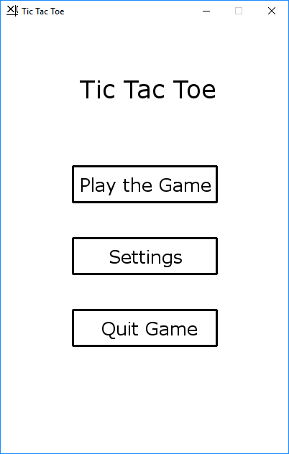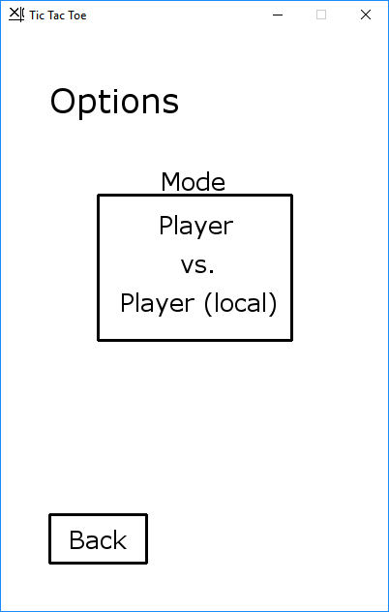

*Main menu Options Menu*

# Game Design (500 words / 1 page)

*You can also discuss what tools (e.g. Tkinter etc) if any you used; what programming techniques (e.g. OOP, functional etc); how you represented the game components (e.g. lists, dictionaries); and how your different functions communicate with each other. You can also discuss how these things changed over the course of the project.*

Command Line – Creating a Tic-Tac-Toe game in the command line was quite simple however it is not very appealing to the user because of the lack of a user interface.

TkInter – TkInter was not chosen to be used with the final game because creating a good user interface using TkInter is quite challenging. The same effect could be created using Pygame while using a lot less code.

Pygame – Pygame seemed to be the logical choice of module when creating the game. This was because it had lots of built in functions and procedures which would help with the development of the game. Using Pygame to create the game allowed us to create the game with much less code than we would have needed without it. This is because Pygame has a built in event checking function which makes finding the position that the user clicked easy. The position is returned in a simple tuple. This is the reason that the final game was created using Pygame.

Game representation – We chose to represent the game’s current state using a single list. We chose to do this because it is a simple way of storing the state of 9 different numbers. We could have used a dictionary using the position on the board as the key for its value. However this seemed to be overcomplicating it. The advantage of using the list is that it was very simple and straight forward.

Networking – The networking portion of the game was separated into two different objects/classes. These were the Server and the Client. We chose to represent the networking using two objects because it allowed for easier communication between the two instances. This seemed like the logical way to handle the networking because this is the architecture which is used globally when handling any type of networking with games. (Other than P2P)

Game menus – Goncalo was the creator of the menus that are used throughout the game. He did this using the Pygame module to draw individual lines to form the user interface.

To begin with, James created the game by separating it into several smaller sections, these made up six classes which were then used. These classes were:

Game_AI – This class handled the AI portion of the game. In our case this class has a function which returns the move of the AI.

Game_Functions – This class has all the functions which will be used while playing Tic-Tac-Toe such as the Take_Turn function.

Server – This class was used to create a socket object which the client would connect to. This class also handles all the server based functionality.

Client – This class handles sending information to the server, as well as the storage of the data which is received.

Main – This class handles the main portion of the game such as running the game and keeping the game window open while it is necessary.

Menus – This class handles all of the drawing of the new screens for the game.

# Project Management

*Describe how you managed the project: how the team divided work, how you communicated, how you managed and merged code, how you came to joint decisions and how you resolved any disputes.*

Managing the project as a group was a challenge at the start as some group members like James and Goncalo had prior knowledge related to our project and were more advanced members of the group. On the other hand, Shivani and Nimra required extra time in specific areas, i.e. networking. However, we did manage to keep up with the tasks and complete them on time, overcoming the hurdles throughout the project.

We had four group members altogether hence why we decided to split into pairs and come up with a simple game code to begin with. Subsequently, both codes did function properly but we chose to work ahead with James and Goncalo’s code and built up from there as a group. Successful group work means everyone in the group contributes to the overall group dynamic. If Shivani and Nimra were behind in editing or contributing in practical, James and Goncalo would carry out the practical and explain the theory to Shivani and Nimra afterwards. So they were ensured that they are up to date with the project.

Furthermore, good group communication is one of the key elements of successful group work, and throughout this project we made sure all team members were contributing towards the project equally and interacted with each other with respect and integrity. Having trust in one another increased the confidence which made it easier for us to interact with each other and make decisions effectively. In addition, to increase our level of communication, we made sure we all stayed in contact outside our Lab hrs, so we made a group chat on WhatsApp, repository on GitHub and exchanged email addresses for further enquiries. Furthermore, we also arranged two group meetings throughout the project to talk about the progression and further plans to implement the project. Therefore, clear communication amongst the group members helped manage the project pretty well.

James managed to create a repository on GitHub and added the rest of the members. This helped us get started on our code as a group and every time each member made a change to the code, we made sure everyone is up to date via group chat on WhatsApp. This made managing and merging the code easier and luckily there was no correlation amongst the members. We agreed on decisions as a group beforehand which made managing the project easier.

Overall, as a group we agreed on individual tasks based on our past experiences and what we were confident to achieve best results in. However, some tasks were quite challenging for Nimra and Shivani, i.e. coding and the networking stage of the game, however James and Goncalo who were more experienced members of the group supported them which is one of the advantages of group work.

# Work Allocation

*Describe which team members did what. If you prefer (or you cannot agree), each team member can write a short statement here.*

As a group we decided to divide the tasks into pairs, as this would broaden our horizons, therefore each group member would contribute towards the project. Shivani and Nimra had started from the basics compared to James and Goncalo who were more advanced regarding the tasks that required programming. Although Shivani and Nimra had created a basic tic-tac-toe game, they had managed to create it successfully. However Shivani and Nimra had found the networking phase of the project very complicated, they had to do additional research regarding the networking. This process required extra time for them to understand the process; however they were unsuccessful in building the network for the game.

James Lee was in charge of the GitHub management and main contributor to the creation of the game along Goncalo. Goncalo created the game menus which are used throughout the game. James created the Networking, the game AI and also the game logic. Furthermore, James also created a text based version of the game and a simple TkInter version of the game. This can all be seen in the history on the GitHub. However, James stopped developing on the other two versions of the game as he decided to work on the Pygame version so they were removed from the GitHub.

# Group Reflection

*As a group reflect on your project: what went well, what did not, what would you have done differently? What else would you have done given more time? What areas needed more time and though and most importantly, what lessons can you learn from this to do better on the next project?*

The main part of the ALL project that went well was the development of the game. Creating the game was interesting and enjoyable, also most of us were able to create a version of the Tic-Tac-Toe game, within python.

A further aspect that went well with the project was how we had prioritised the project. This is because we had always referred back to the project plan and the lab sheets in order to ensure that everything was going to plan, and to ensure that what we were doing was correct. In addition this had helped us acknowledge how far we was from completing the project, and what we had to do in order to complete it successfully.

However an aspect that did not go so well was the networking in particular for Shivani and Nimra as they had struggled with understanding this stage of the game development. However even James and Goncalo had some difficulties while getting the AI, which had taken a while to fix. Therefore if we could do anything differently we would like to research individually before the project, regarding networking.

If we had more time, we would’ve fixed many of the bugs present in the game, which implies improving the robustness of the code, especially the networking sections and would also add some missing functionalities, such as harder AI.

Overall the project was nearly successful, this is because our group had effectively time managed the project, by setting out realistic due dates and begin dates. Although the project management skills have not been perfect, there are many important lessons and skills we have learnt from doing this project. A further thing that could have been improved upon was our coding skills, as we have developed a basic knowledge of how Python works and are able to successfully create a simple game on Python.

Furthermore the project has also allowed for our group to learn valuable interpersonal skills such as listening, communication and independent working that will be applied to future projects.